**Homework 3: Sequence Logo Visualization**

1081546 萬彥君

1.Install Python and creat a new directory for project and navigate to it in the terminal.

2.Set up a virtual environment by running the following command.



3.Activate the virtual environment in Windows by running the following command:



4.Install flask,matplotlib,and numpy using pip

Ex: pip install flask matplotlib numpy

5.Create a new Python file named”hw3.py”,then open to add code in this file.

6.In additional, create a HTML templates and create a new HTML file named ”index.html” ,then open to add code in this file.

7.In the terminal,run the flask application by executing the following command:



8.Open web brower and visit “<http://127.0.0.1:5000>”.

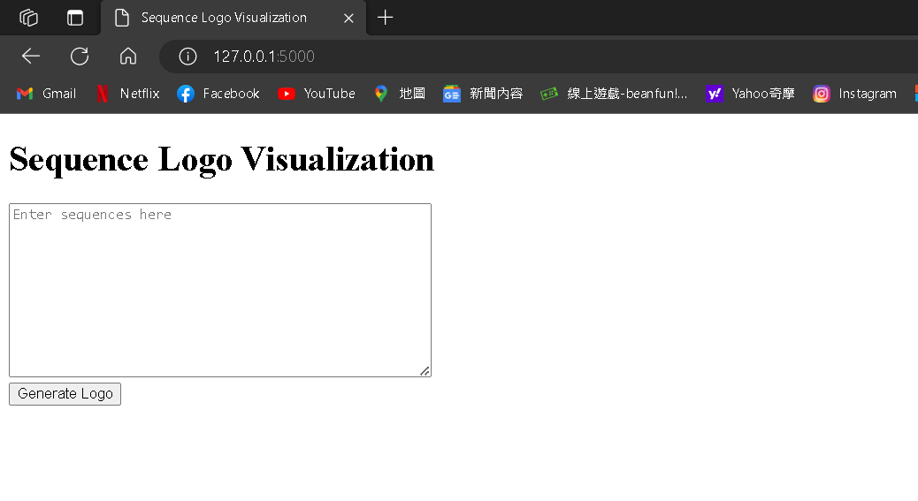

9.Finally, we can see the input form for sequences.Enter the sequences in the input box,separated by new lines,and click the “Generate Logo” button.

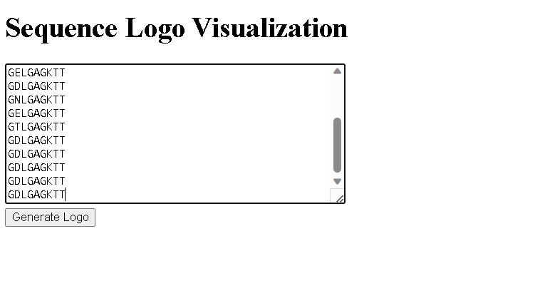

10.The application will generate the logo and save it as “logo.jpg”,”logo.png” and “logo.svg” in the project directory.

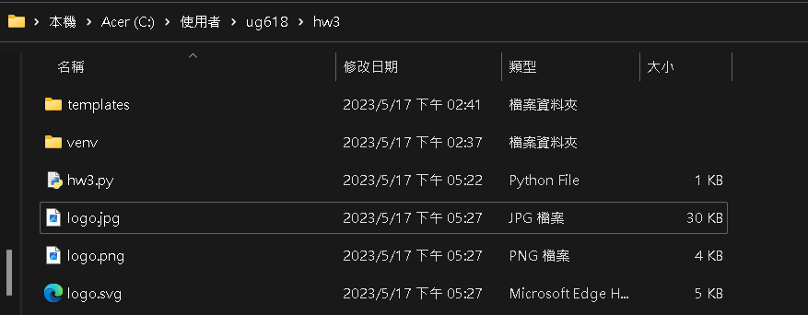

The following picture is the output of “logo.jpg”.

